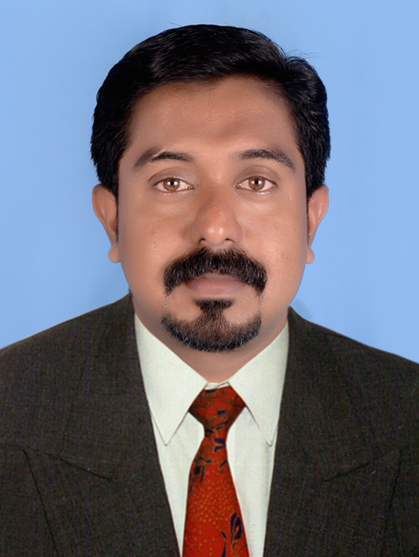
JITHIN JOSEPH
E-mail: jithin864u@gmail.com
Skype : jithin864u@gmail.com
Mobile No:+971-58 209 9216
Whatsapp : +91-92 0739 6010

CAREER OBJECTIVE
To Update my knowledge with newer cutting edge technologies and work in a challenging environment where I can implement my knowledge towards workable solutions. I am a hard working professional with the focus towards organizational and personal growth.
PROFESSIONAL EXPERIENCE
- 4 years experience as FINANCE MANAGER Cum ADMINISTRATOR in ZAM ZAM MEDICAL CENTER, SAUDI ARABIA (June 2012 to April 2016)

CLINICS & PHARMACY

- Preparation of Books of Accounts.
- Bank and Bank Reconciliation.
- Preparation of Final Accounts.
- Managing with Purchases.
- Preparation of Payroll
- Preparation of Duty Schedules
- Payments to Suppliers and Company purpose.
- Verification of Inventory
- Preparation of Zakka
- Submission and Checking of Medical Insurance

- 1 year experience as ACCOUNTS OFFICER in WEDLAND SILKS AND SAREES, KOLLAM (Jun 2011 to May 2012)

1. Prepare Books of Accounts.
2. Bank and Bank Reconciliation.
3. Purchase and Sales.
4. Compliance with Statutory Forms
5. Sales Tax and TDS.
6. Issue of ‘C’ forms.
7. Payroll Preparation
8. Payments to Suppliers and Company purpose. Profit and Loss accounts.
9. Preparation of Final accounts.

- 2 years experience as ACCOUNTS OFFICER in CLASSIC POLO (Aug 2009 to May 2011)( Part time)

- Preparation of Books of Accounts
- Purchase and Sales.
- Final accounts

- 1 year experience as AUDIT ASSISTANT with a reputed CHARTERED ACCOUNTANT FIRM, KOLLAM ( Jun 2008 to Jun 2009)

- Company Audit
        - Checking & correcting the books of accounts.
- Bank Audit (South Indian Bank & Union Bank)
        - Checking & correcting the Book of Accounts.
        - Verify the Cash and Gold
        - Verify the Loans

- 5 months experience as Accounts Assistant in POWERSHELL POLYMERS INDIA PVT.LTD, KOLLAM (Jan 2008 to May 2008) (Part time)

- Prepare Books of Accounts
- Purchase and Sales.
- Final accounts

EDUCATIONAL QUALIFICATION
- MBA (Finance & HR) in 2011 from Anna University, Tamilnadu.
- B.Com-passed in 2008 under Kerala University, Kerala.
- PLUS 2- Passed in 2005 under Board of Higher Secondary Examination, Kerala.
- S.S.L.C- Passed in 2002 under Board of Public Examination, Kerala.

SOFTWARE EXPOSURE
- Operating System : WindowsXP, Windows 7,Windows 10.
- Software Languages : Tally 9 & ERP 9
- Publishing Package : MS-Office, Photoshop.
- Other Skills :Excellence in Internet usage,
Formats and Installs the Software’s

OTHER ACHIEVEMENTS
- Participated in different social welfare activities like volunteer blood donation.
- Award winner in different arts competitions like drama, mime, fancy dress, drawing and painting.
- Participated in many sports competitions like cricket, badminton and Basket ball.
PERSONAL SKILLS
- Comprehensive problem solving abilities
- Ability to get along well with colleagues
- Good verbal and written communication
- Ability to work in any Environment

PERSONAL PROFILE

Name : JITHIN J

Father’s Name : JOSEPH ANTONY

Sex : Male

Age & Date of Birth : 30 years, (19/06/1986)

Marital Status : Single

Languages Known : English ,Hindi, Malayalam, Tamil and Arabic

Religion : Christian

Nationality : Indian

Permanent address : “Veliyippad”, Pavithram Nagar-7,
Vadakkumbhagam,
Eravipuram P.O Kollam,
Kerala 691011

PASSPORT DETAILS
Passport Number : P0251108
Date Of Issue : 02/08/2016
Date Of Expiry : 01/08/2026
Place Of Issue : Trivandrum

DECLARATION

I hereby declare that the information contained in my Curriculum Vitae are true to the best of my knowledge.

Place : KOLLAM Your's sincerely,
Date : JITHIN.

